22EE450-Power Electronics
Assignment 2

Submission due date: 30.04.2026

1.
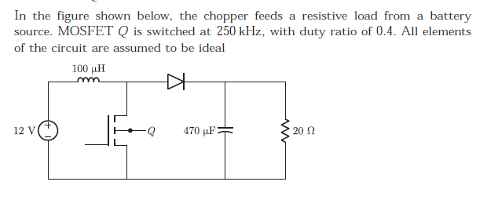 Find
(a)The Peak to Peak source current ripple in amps is
(b) The average source current in Amps in steady-state is

2.
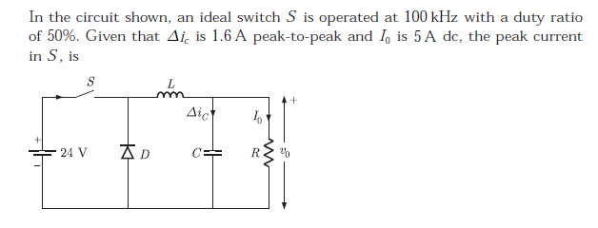
3.
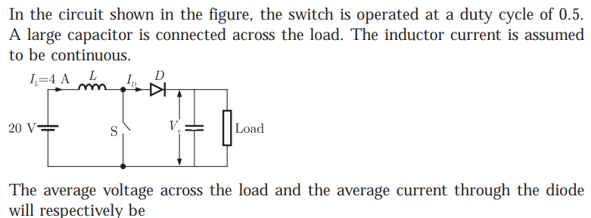
- A dc chopper has an input voltage of 200V and a load of 8 ohm resistance. The voltage drop across thyristor is 2V and the chopping frequency is 800 Hz. The duty cycle is 0.5. Find, i) average output voltage ii) RMS output voltage iii) chopper efficiency and iv) input resistance seen by the source.

- A step-up chopper has a supply voltage of 100V and output of 250V. If the ‘off’ period of chopper is 150µs, a) determine the pulse width of output voltage. b) find the output voltage if pulse width is reduced to ½ for constant frequency operation.

- A buck-boost regulator has an input voltage, Vs=10V. The duty cycle k=0.25, the average load current, Ia=1A and the switching frequency is 25kHz. If L=150μH and C=220μF, calculate (i) the average output voltage, (ii) the ripple current of L, (iii) the ripple voltage of C.

- A single phase full wave AC voltage controller has an input voltage of 230V, 50 HZ and it is feeding a resistive load of 10 ohms. If firing angle of thyristor is 110 degree, find the output RMS voltage, input power factor and average current of thyristor.

8.
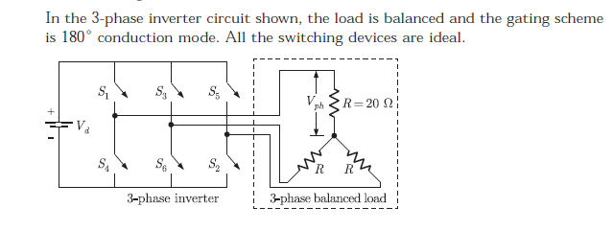
(a) The rms value of load phase voltage is_______
(b) If the dc bus voltage Vd = 300 V, the power consumed by 3-phase load is_______

